Example No 01:

Input:

using System;

namespace Computer_Programming_Lab_08

{

class Program

{

static void Main(string[] args)

{

int m = 5; //Rows

int n = 4; //Col

string[,] profile = new string[m, n];

//titles

profile[0, 0] = "Name";

profile[0, 1] = "Phone No";

profile[0, 2] = "Designation";

profile[0, 3] = "Department";

//row 1

profile[1, 0] = "Abdullah";

profile[1, 1] = "000000000";

profile[1, 2] = "Jr.Dev";

profile[1, 3] = "BSE";

//row 2

profile[2, 0] = "Shahzaib";

profile[2, 1] = "000000000";

profile[2, 2] = "Sr.Dev";

profile[2, 3] = "BSCS";

// Printing of 2D Array

for (int i =0; i<m; i++)

{

for (int j = 0; j < n; j++)

{

Console.Write("{0}\t\t",profile[i,j]);

}

Console.WriteLine();

}

}

}

}

Output:

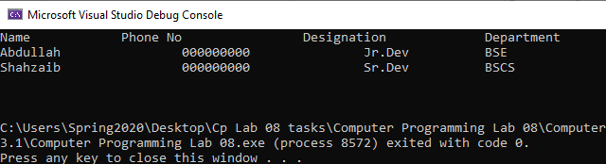

Example No 02:

Input:

using System;

namespace CP_Lab_Tasks

{

class Program

{

static void Main(string[] args)

{

int m;

int n = 4;

Console.Write("Enter the number of student : ");

m = int.Parse(Console.ReadLine());

string[,] profile = new string[m + 1, n];

//For title

profile[0, 0] = "NAME";

profile[0, 1] = "AGE";

profile[0, 2] = "COURSE";

profile[0, 3] = "SEMESTER";

//Inputing the values for the table

for (int i = 1; i < m + 1; i++)

{

Console.WriteLine("\nEnter data for profile {0}", i);

for (int j = 0; j < n; j++)

{

if (j == 0)

{

Console.Write("Enter the name of the student : ");

profile[i, j] = Console.ReadLine();

}

else if (j == 1)

{

Console.Write("Enter the age of the student : ");

profile[i, j] = Console.ReadLine();

}

else if (j == 2)

{

Console.Write("Enter the course of the student : ");

profile[i, j] = Console.ReadLine();

}

else if (j == 3)

{

Console.Write("Enter the semester of the student : ");

profile[i, j] = Console.ReadLine();

}

}

}

for (int i = 0; i < m + 1; i++)

{

for (int j = 0; j < n; j++)

{

Console.Write(" " + profile[i, j].PadRight(10));

}

Console.WriteLine();

}

Console.ReadLine();

}

}

}

Output:

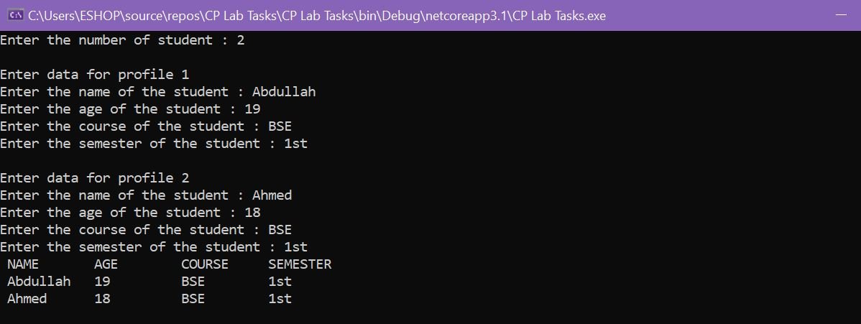

Task No 01: Enter the first matrix and then display it. Secondly, enter the second matrix and then display it. In the result by apply 2D arrays show Addition, subtraction of 2 matrixes.

Input:

using System;

namespace CP_Lab_Tasks

{

class Program

{

static void Main(string[] args)

{

int rows1, rows2, col1, col2;

Console.Write("Enter the number of rows for matrix 1 : ");

rows1 = int.Parse(Console.ReadLine());

Console.Write("Enter the number of columns for matrix 1 : ");

col1 = int.Parse(Console.ReadLine());

Console.ReadLine();

Console.WriteLine("Enter the elements of first matrix");

int[,] matrix1 = new int[rows1, col1];

for (int i = 0; i < rows1; i++)

{

for (int j = 0; j < col1; j++)

{

Console.Write("Enter the element ({0},{1}) = ", i, j);

matrix1[i, j] = int.Parse(Console.ReadLine());

}

}

for (int i = 0; i < rows1; i++)

{

for (int j = 0; j < col1; j++)

{

Console.Write(" " + matrix1[i, j]);

}

Console.WriteLine();

}

Console.Write("Enter the number of rows for matrix 2 : ");

rows2 = int.Parse(Console.ReadLine());

Console.Write("Enter the number of colums for matrix 2 : ");

col2 = int.Parse(Console.ReadLine());

Console.ReadLine();

Console.WriteLine("Enter the elements of first matrix");

int[,] matrix2 = new int[rows2, col2];

for (int k = 0; k < rows2; k++)

{

for (int l = 0; l < col2; l++)

{

Console.Write("Enter the element ({0},{1}) = ", k, l);

matrix2[k, l] = int.Parse(Console.ReadLine());

}

}

for (int k = 0; k < rows2; k++)

{

for (int l = 0; l < col2; l++)

{

Console.Write(" " + matrix2[k, l]);

}

Console.WriteLine();

}

Console.ReadLine();

int[,] result = new int[rows1, col2];

for (int i = 0; i < rows1; i++)

{

for (int j = 0; j < col2; j++)

{

result[i, j] = 0;

for (int k = 0; k < col1; k++)

{

result[i, j] = result[i, j] + matrix1[i, k] * matrix2[k, j];

}

}

}

Console.WriteLine("After Multiplication result is\n");

for (int i = 0; i < rows1; i++)

{

for (int j = 0; j < col2; j++)

{

Console.Write(result[i, j] + " ");

}

Console.WriteLine();

}

}

}

}

Output:

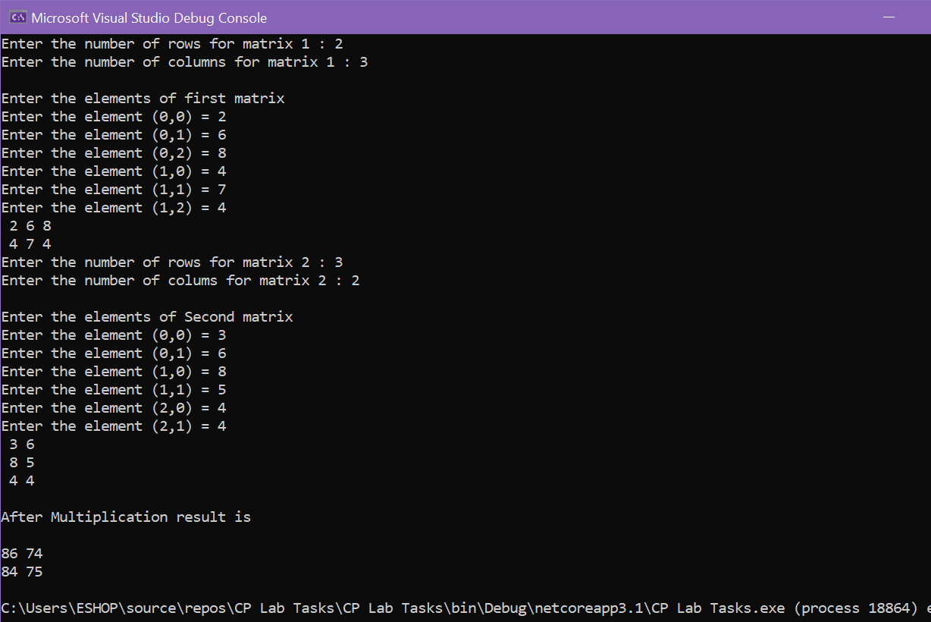

Task No 02: Take N number of user data input and make sure N is greater than 10, which contain name of the user, his/her nationality, and his/her eye color. You must show the max color of eye in each country.

Input:

using System;

namespace CP_Lab_Tasks

{

class Program

{

static void Main(string[] args)

{

Console.WriteLine("Enter number of users");

int N = int.Parse(Console.ReadLine());

int C = 3;

string[,] a = new string[N, C];

a[0, 0] = "Name";

a[0, 1] = "Nationality";

a[0, 2] = "Eye Color";

int brown = 0, green = 0, black = 0, grey = 0, blue = 0;

for (int i = 0; i < N; i++)

{

for (int j = 0; j < C; j++)

{

if (i != 0 && j == 0)

{

Console.WriteLine("Enter Name {0}", i);

a[i, j] = Console.ReadLine();

}

if (i != 0 && j == 1)

{

Console.WriteLine("Enter Nationality {0}", i);

a[i, j] = Console.ReadLine();

}

if (i != 0 && j == 2)

{

Console.WriteLine("Enter EyeColor {0}", i);

a[i, j] = Console.ReadLine();

if (a[i, j] == "Brown" || a[i, j] == "brown")

{

brown++;

}

if (a[i, j] == "Green" || a[i, j] == "green")

{

green++;

}

if (a[i, j] == "Black" || a[i, j] == "black")

{

black++;

}

if (a[i, j] == "Grey" || a[i, j] == "grey")

{

grey++;

}

if (a[i, j] == "Blue" || a[i, j] == "blue")

{

blue++;

}

}

}

}

Console.Clear();

for (int i = 0; i < N; i++)

{

for (int j = 0; j < C; j++)

{

Console.Write("{0,16} ", a[i, j]);

}

Console.WriteLine();

}

Console.WriteLine("Total Brown eyes = {0}", brown);

Console.WriteLine("Total Green eyes = {0}", green);

Console.WriteLine("Total Black eyes = {0}", black);

Console.WriteLine("Total Grey eyes = {0}", grey);

Console.WriteLine("Total Blue eyes = {0}", blue);

}

}

}

Output:

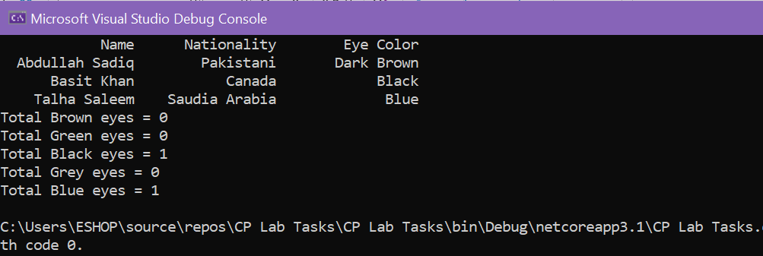

Task No 03: Make a program in C# in which take no. of items, price of items, quantity of items and name of items as input from the user and give the discount according to the following conditions (Use 2D Array):

1. If from rice give discount of 30%.
2. Else if the total amount is greater than 50,000 and less than 100,000 give discount of 20%.
3. Else if the total amount is greater than 100,000 give discount of 30%.

Input:

using System;

namespace CP_Lab_Tasks

{

class Program

{

static void Main(string[] args)

{

int n;

int total = 0;

double d = 1, dtotal = 0;

Console.WriteLine("Enter No. of items:");

n = int.Parse(Console.ReadLine());

string[,] item = new string[n, 3];

for (int x = 0; x < n; x++)

{

Console.Write("\nEnter name of item {0} : ", x + 1);

item[x, 0] = Console.ReadLine();

if (item[x, 0] == "rice" || item[x, 0] == "Rice")

{

d = 0.7;

}

Console.Write("Enter price of {0} : ", item[x, 0]);

item[x, 1] = Console.ReadLine();

Console.Write("Enter quantity of {0} : ", item[x, 0]);

item[x, 2] = Console.ReadLine();

total += (int.Parse(item[x, 1]) * int.Parse(item[x, 2]));

}

if (d != 0.7)

{

if (total >= 50000 & total <= 100000)

{

d = 0.8;

}

else if (total > 100000)

{

d = 0.7;

}

}

dtotal = total * d;

Console.WriteLine("#\t\tName\tPrice\t\tQuantity\n");

for (int x = 0; x < n; x++)

{

Console.Write("{0}", x + 1);

for (int y = 0; y < 3; y++)

{

if (y == 1)

{

Console.Write("\t\t${0}", item[x, y]);

}

else

{

Console.Write("\t\t" + item[x, y]);

}

}

Console.WriteLine();

}

Console.WriteLine("\n\tTotal : " + total);

if (d != 1)

{

Console.WriteLine("\n\tTotal after discount of {0}% is : ", (1 - d) *100, dtotal);

}

}

}

}

Output:

